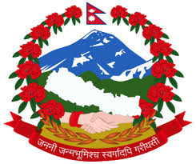
g]kfnL sG;'n]6 hg/n القنصلية العامة النيبالية
h]2f, ;fpbL c/a جدة المملكة العربية السعودية
NEPALESE VISA APPLICATION FORM
Photo
The Consul General/Consul,
As I have to visit/ would like to visit Nepal, I request for the issuance of
Diplomatic Official Tourist entry Visa.
My details are as follows:
1. Full Name: 2. Nationality:
3. Place of Birth: 4. Date of Birth:
5. Permanent Address: 5a. Phone No.:
5b. E-mail: 6. Occupation:
7. Passport No.: 7a. Date and Place of Issue:
7b. Date of Expiry: 8. Purpose of Visit:
8a. Expected date of arrival in Nepal:
9. Temporary Address in Nepal:
10. Number of Previous Visits:
11. Source of expenditure while staying in Nepal (please check one) Self Sponsor
12. Year, month and duration of last visit:
13. Are you holding a passport of any other country? Yes No
If yes, please mention 16a. Passport No.: 16b. Country:
Please check any one of the following:
SR 100 for 15 days (multiple)
SR160 for 30 days (multiple) SR400.00 for 90 days (multiple)
……………………… ………………………..
Signature of the applicant Date:
For official use only
1. Type of Visa: 2. Reason for Gratis, if any:
3. Entry Visa number: 4. Date of Issue:
5. Date of Expiry 6. Visa Sticker Number:
........................................................
Issuing Officer
Tel,: +966-126226665, 6226683, Fax: +966-12-6225339 , Email: cgnjeddah@mofa.gov.np

